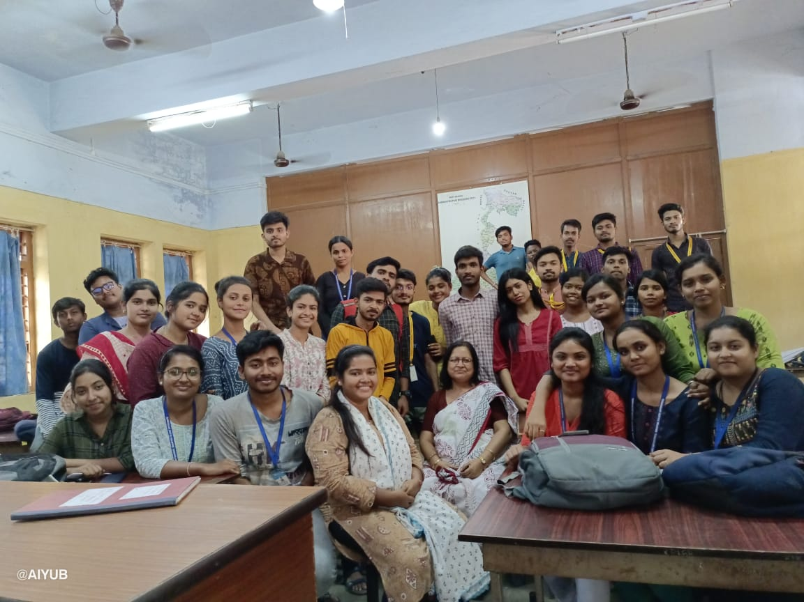
Mentor group meeting with students, Department of Geography

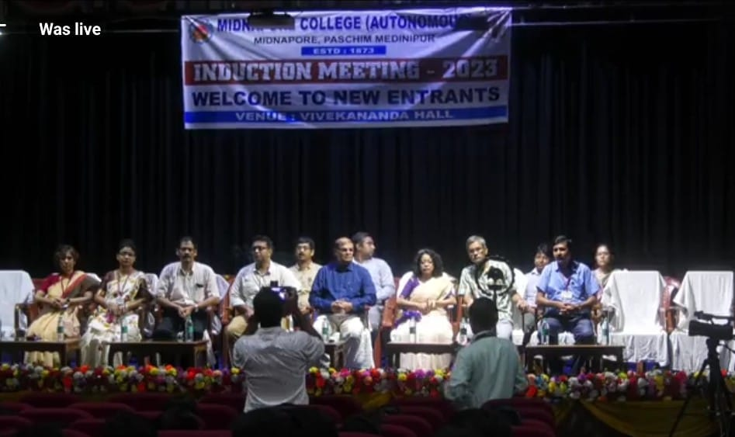
Induction meeting with the new entrants of the college
https://fb.watch/xuBkt7W4cK/

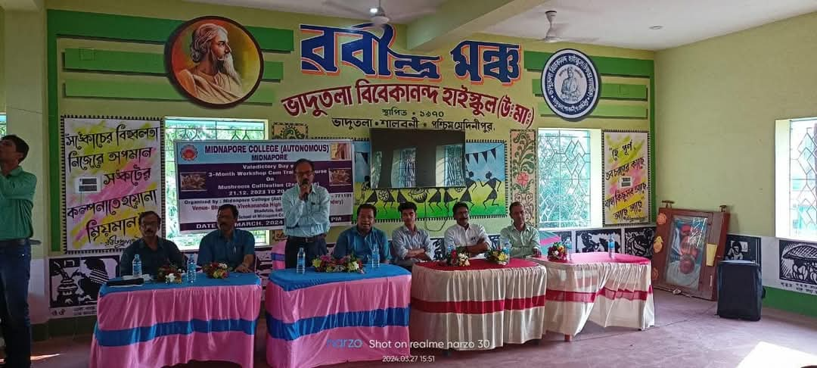
Workshop on mushroom culture in the adopted school of the college

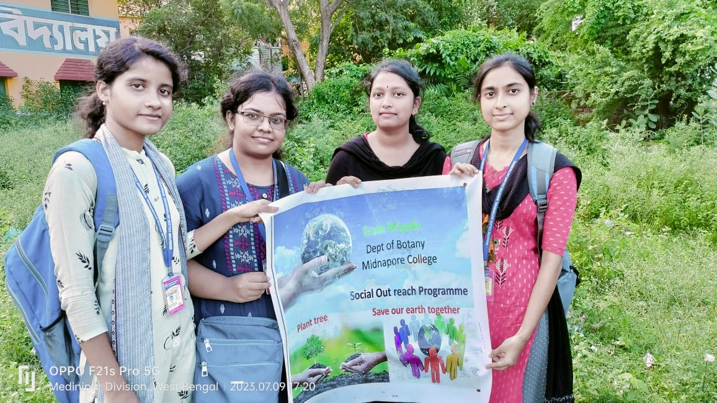
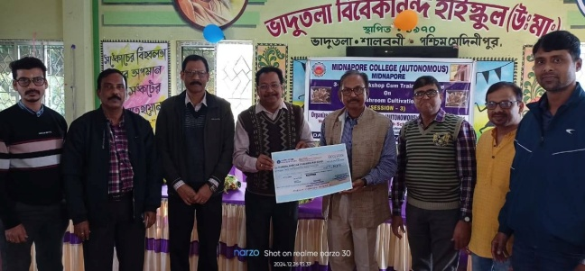
Social forestry program by the students of the college in nearby schools

