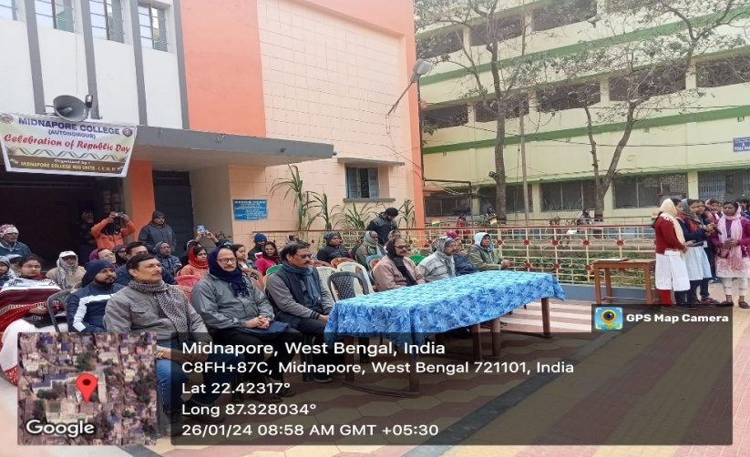
Component 7.1.11.b
Republic Day Celebration

National Space Day Celebration

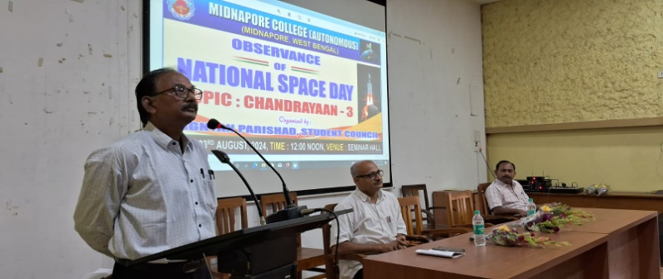
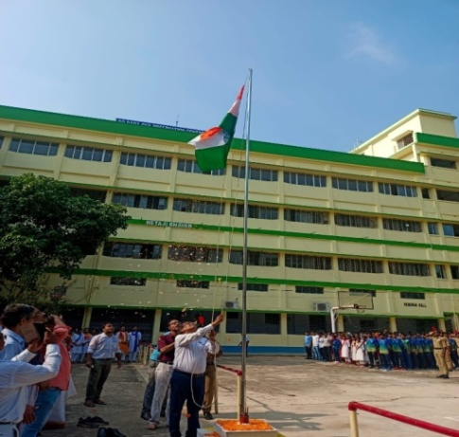
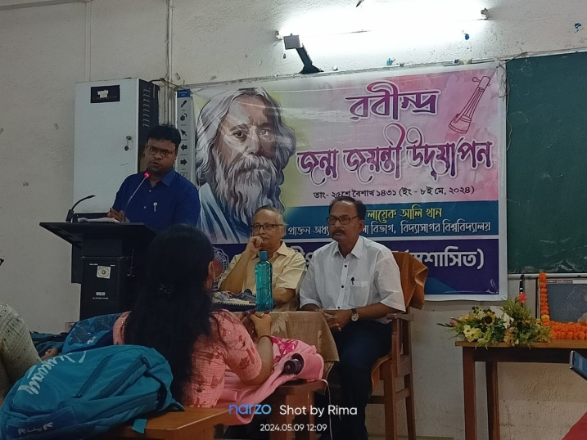
Independence Day Celebration
Birth Day Celebration of Rabindranath Tagore
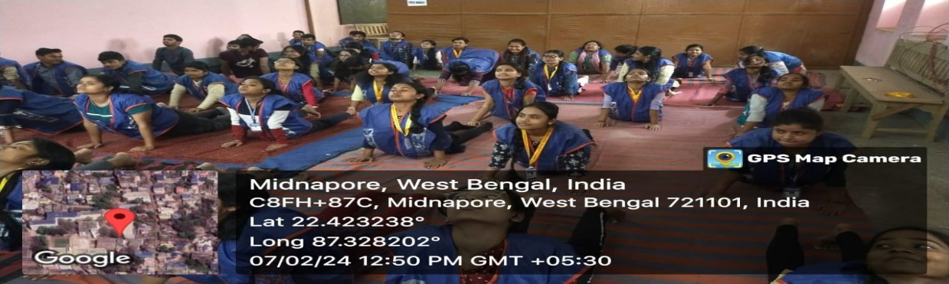
International Yoga Day Celebration

