Midnapore College (Autonomous)
Midnapore

Details of Available Bandwidth:
1 JIO Leased Line Connection: 20 MBPS
2 Nos. Alliance Broadband Connection: 100 MBPS Each
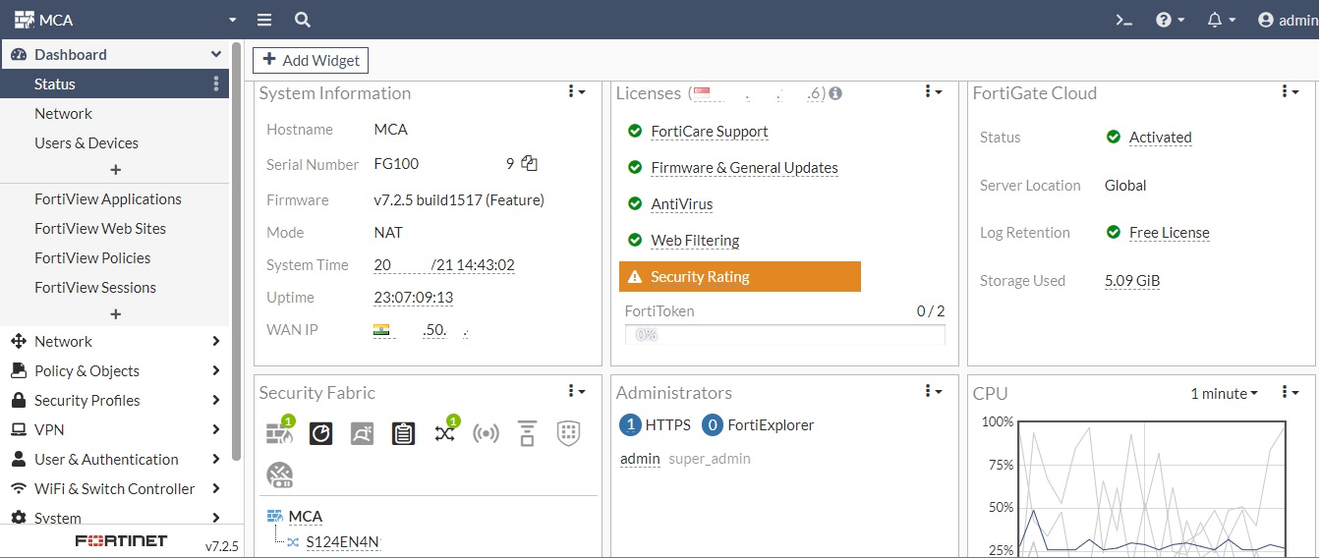
1 ILL Broadband Connection: 100 MBPS
All are well maintained by Firewall System.

